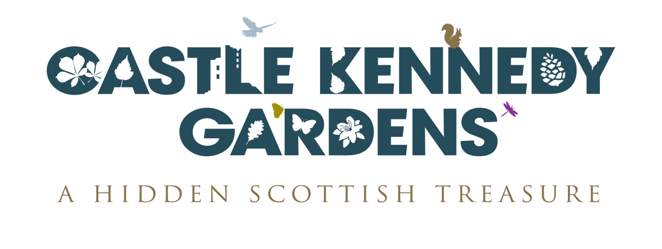

Opportunities to Volunteer

We would be pleased to have individuals become more involved with the work of the Garden and its activities through becoming a volunteer.
Volunteers will be able to participate in the work of Castle Kennedy Gardens in many ways; however, the main role of the volunteer is to increase the educational value, interest and enjoyment of a visit to the Garden.
There are opportunities within the existing Gardening Department as well as with Education Marketing. In addition we are keen to develop a new team of Volunteer Garden Rangers.
If you are interested in volunteering with us please complete the application form below and either hand it in to a member of staff or send it to:
Volunteers
Castle Kennedy Gardens
Sheuchan
Castle Kennedy
Dumfries & Galloway DG9 8SL
or email it to: enquiries@castlekennedygardens.com

Application Form
Personal Details:
name:
(first) |  | (middle) |  | (family)
address:
(address 1) |  | (address 2) |  | (town/ city)
(county) |  | (post code)
email:
telephone:
gp name & address
next of kin
name & address
next of kin contact telephone no

Preferred Area of Work (Please identify a First and Second Choice)
 | General gardening |  |  | Public Events/Activities
 | Wildlife |  |  | Schools/Education
 | Garden Guides |  |  | Membership
 | Marketing

Any other relevant information in support of your application:
(e.g. previous volunteer experience or other similar organisations)

Please explain what you hope to achieve from voluntary work at the Gardens:

Please indicate your availability: (i.e. Preferred days/times of the week)
days of weeks |  |  | time of day
 | Sundays |  |  | Mornings
 | Mondays |  |  | Afternoons
 | Tuesdays |  |  | Evenings
 | Wednesdays |  | time of year
 | Thursdays |  |  | Spring (Easter – June)
 | Fridays |  |  | Summer (July-August)
 | Saturdays |  |  | Fall (September-October)
 |  |  |  | Winter (November – Easter)

Please provide the name and email/contact details for two References:
1.
2.

Security: All successful applicants may be required to provide a Basic Disclosure Certificate less than 12 months old prior to taking up a placement. Further information on Disclosure Certificates can be found at the Disclosure Bureau’s website www.disclosurescotland.co.uk

Data Protection: The information on this form will be used for the purpose of selection for volunteering opportunities. Access to the data will be restricted to your relevant volunteer co-ordinator. The form will be placed on your personal file.

